SONU KUMAR
Contact Details: +91-9873706831
Email id: sinsinwarsonu4@gmail.com

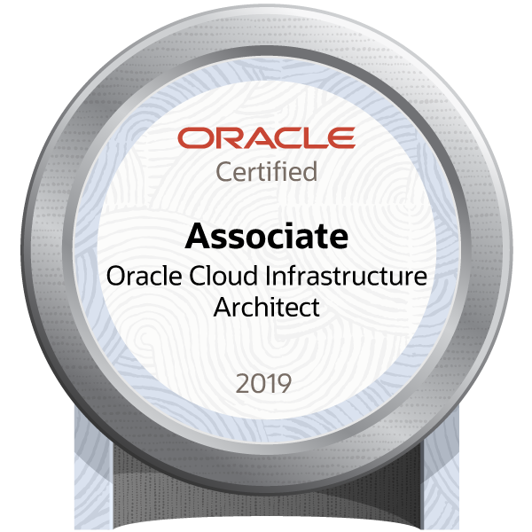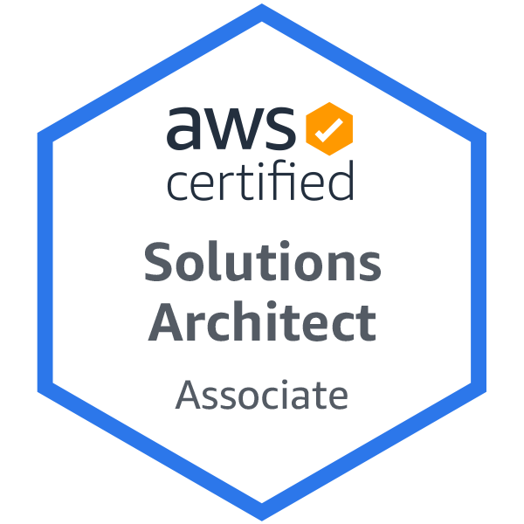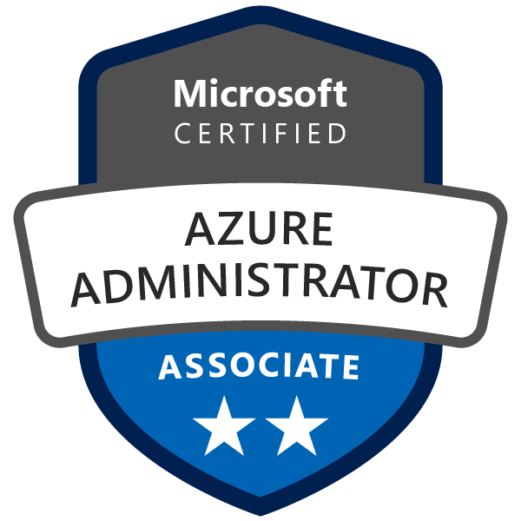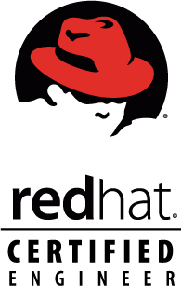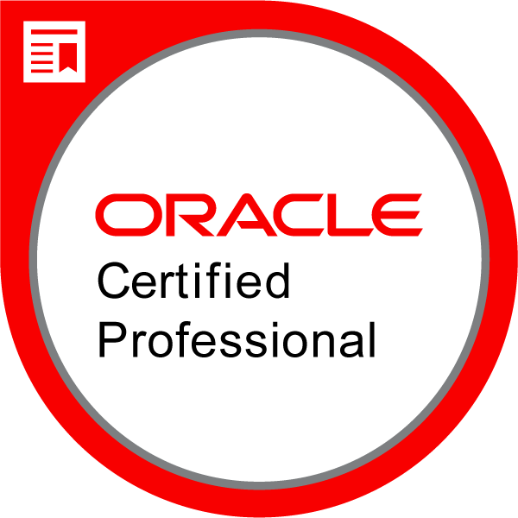

CAREER OBJECTIVE:
With dedication, focus, proactive approach and positive attitude, I look forward to pursuing a long-term career in your organization fulfilling company goals and customer satisfaction by utilizing my knowledge and skills in the best possible way.

ACADEMIC CREDENTIALS:
- Bachelor of Engineering (Electronics & communication) from Institute of Engineering & Technology in 2005-2009 under University of Rajasthan.

CERTIFICATION:
- Oracle Cloud Infrastructure Foundations Certified Associate
- Oracle Cloud Infrastructure Certified Architect Associate
- AWS Certified Solutions Architect – Associate
- Microsoft Certified: Azure Fundamentals
- Microsoft Certified: Azure Administrator Associate
- Oracle Solaris 10 System Administrator Certified Professional (SA-1 & SA-2)
- Red Hat Certified System Administrator (Certification ID: 180-245-169)
- Red Hat Certified Engineer (Certification ID: 180-245-169)

WORK HISTORY & EXPERIENCE:

- Current Organization: Rackspace Technology
- Joined: July 2017 (Currently Serving Notice Period)
- Designation: Cloud Engineer-II

- Previous Organization: HCL Technologies-IOMC
- Duration: December 2013 to July 2017
- Designation: Senior Specialist

- Previous Organization: Wipro InfoTech
- Duration: July 2011 to December 2013
- Designation: Customer Service Engineer

TECHNICAL SKILLS:
- Cloud Technology: OCI, AWS, Azure
- Container Technology: OpenShift, Docker, Kubernetes
- Virtualization Environment: OLVM, OVM, VMware vSphere, Solaris LDOMs, Solaris Zones, KVM
- Configuration management Tool: Ansible
- Operating systems: Solaris, Linux (RHEL, OEL, Centos), AIX
- Shell Scripting: bash
- Ticketing Tools: BMC Remedy, Service Now, Issuetrek, Core, JIRA

PROJECTS and CLIENTS:
- BSNL CDR – East India (Kolkata)
- BSNL CDR – North India (Chandigarh & Panipat)
- Airtel, Reliance, Idea, TATA: Worked as a Unix Field Engineer (Chandigarh)
- HCL – NCR Global (Noida)
- Currently working with 30+ Remote clients in Cloud ops Team as a Cloud engineer-II with Rackspace.

JOB RESPONSINILTIES:

- To Administer & Manage a large base of UNIX (Solaris, Linux & AIX) servers that host several critical business applications, databases, etc.
- Experienced with the implementation, architecture and operation of an on-premises containerized environment like Docker, Kubernetes and OpenShift.
- Hands-on configuration, management of Kubernetes and OpenShift platform
- Build Kubernetes on AWS with Route53 from scratch
- Worked on creating new Projects, Services for load balancing and adding them to Routes to be accessible from outside, troubleshooting pods through ssh and logs, modification of Buildconfigs, templates, Imagestreams, etc.
- Manage Ansible playbooks for automatic deployment and configuration of RHEL servers for test and prod environments.
- Troubleshoot all the issues related to Operating Systems and provide support for the entire Instances of OCI, AWS, OLVM, OVM and physical servers.
- Applying OS updates and installing packages on Solaris, Linux servers.
- OS tuning adjustments in Linux and Solaris Operating System.
- Firmware upgrade on Solaris Sparc and X86 machines & Linux Blade servers
- VM provisioning using ansible and templates in OLVM, OVM, VMware and cloud environment (OCI & AWS).
- Setup/Manage Linux Servers on OCI & Amazon.
- Create/Manage AMI/Snapshots/Volumes, Upgrade/downgrade AWS & OCI resources (CPU, Memory, EBS)
- Investigation and Recover of Production Server Issues like as Server load
- Monitor Server Health of different parameters (System Load, Physical Memory, Swap Memory, Hard disk).
- Create AWS & OCI Instances and Resources Bills.
- OS installation on Solaris Sparc models using custom Jumpstart Deployment and for Linux VM through templates.
- User, group, and policy administration in OCI, AWS and for Unix servers.
- Troubleshooting work on Linux/Solaris instances, VM’s and Physical Server when they become inaccessible.
- Worked on performance issues ranging from CPU, MEM, I/O, N/W, etc.
- Manage and configure Solaris Zones, LDOMs, OLVM (Virtual environment).
- Handle the change management (SERVICE NOW) in accordance with ITIL standards for driving completion of all scheduled changes.
- Coordinate with vendors like IBM, Oracle, and Dell.
- Perform Boot and shutdown procedures.
- Perform File system management and configuration in ZFS.
- Worked on Solaris Volume Manager and Performed all types of tasks like mirroring, Meta database creation, Soft Partition Creation, Replacement of failed disks & Assigning Hot Spare Pools
- Troubleshooting and Resolving Technical Problems related to VCS and VxVM.
- Installation and Configuration of VERITAS Cluster and VERITAS Volume Manager Software.

PERSONAL PARTICULARS:

- Name: Sonu Kumar
- Father's Name: Naval Singh
- Date of Birth: May 1st, 1989
- Languages Proficiency: English, Hindi
- Marital Status: Married
- Passport: Yes

DECLARATION: I do hereby declare that the information provided above is true to the best of my knowledge and belief.

(Sonu kumar)

